**ASSIGNMENT 4 (Part 2)**

Query 7:

Create a function to change the case of a string. As Follows.  
          This is A TEST String  
          becomes           
          tHIS IS a test sTRING

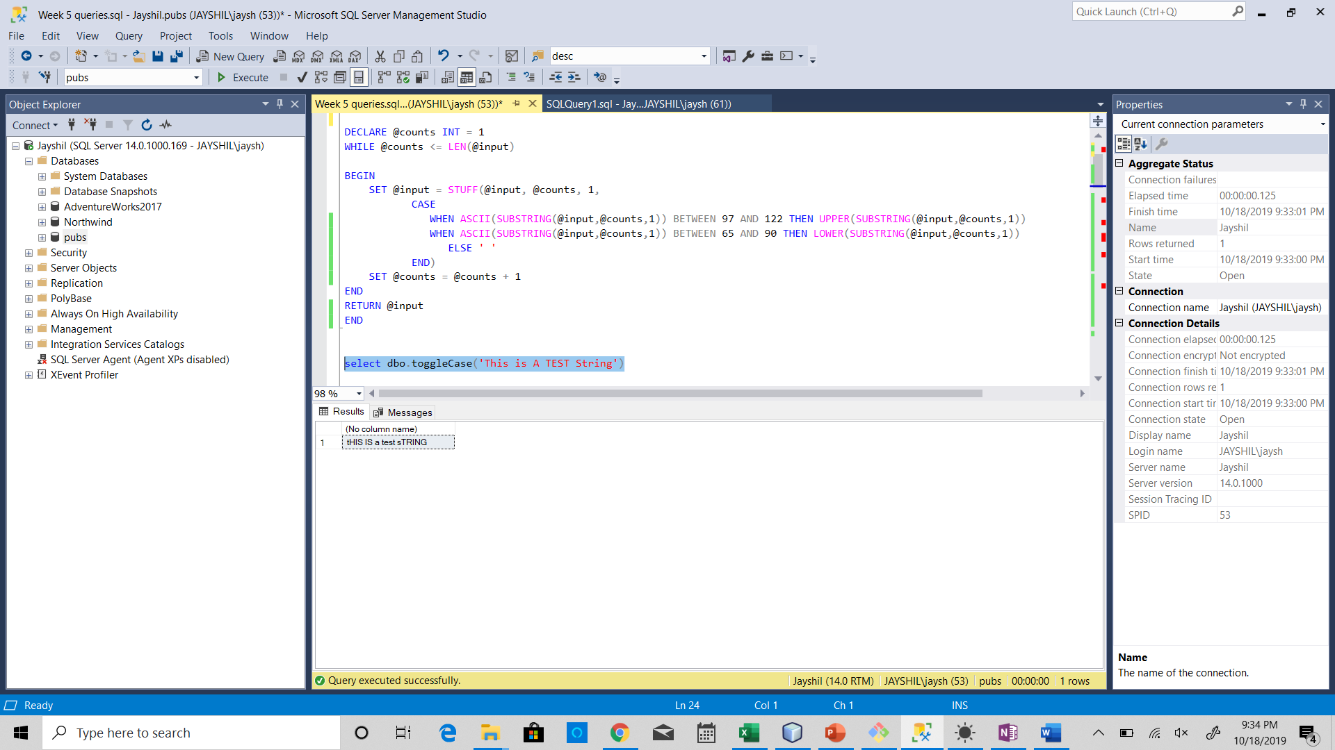

Query 8:

Create a function to return the gender of an employee based on the emploee id (gender is Male / Female)

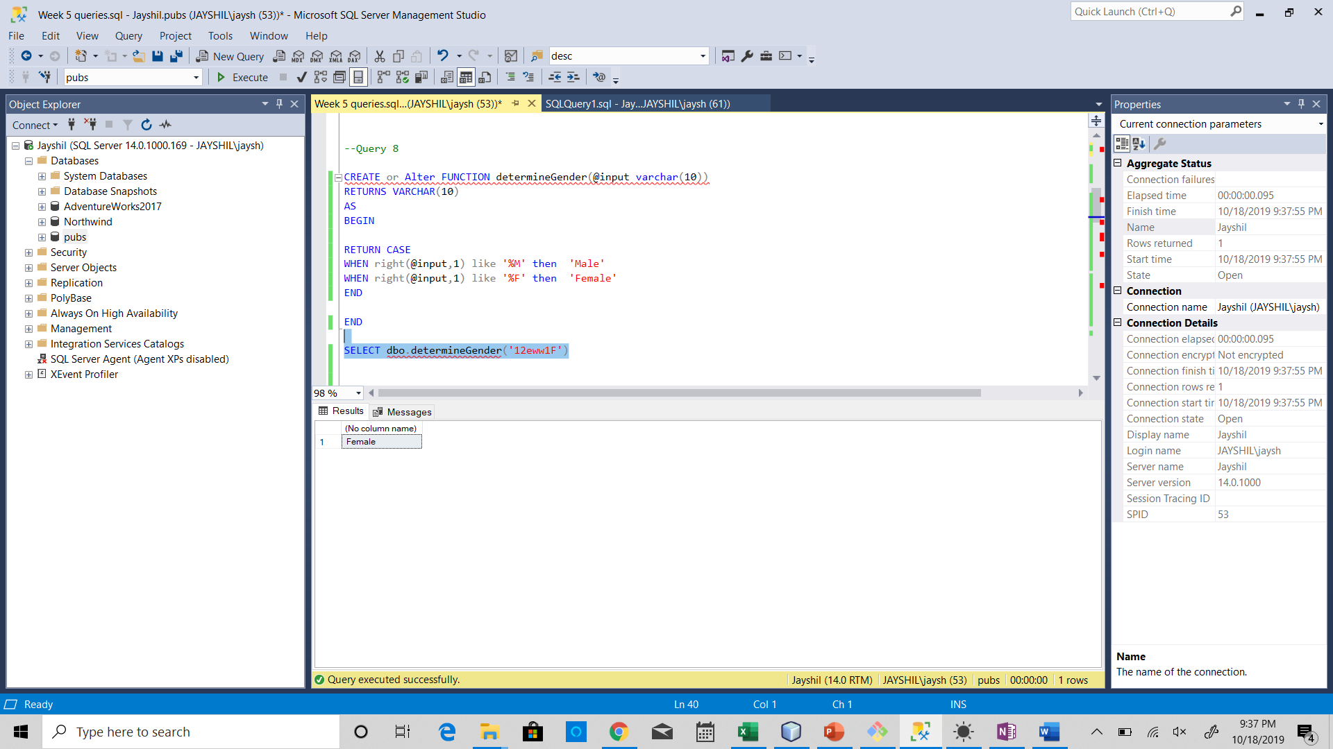

Query 9: Create a table function that returns the employee columns and a new row called gender (again Male / Female)

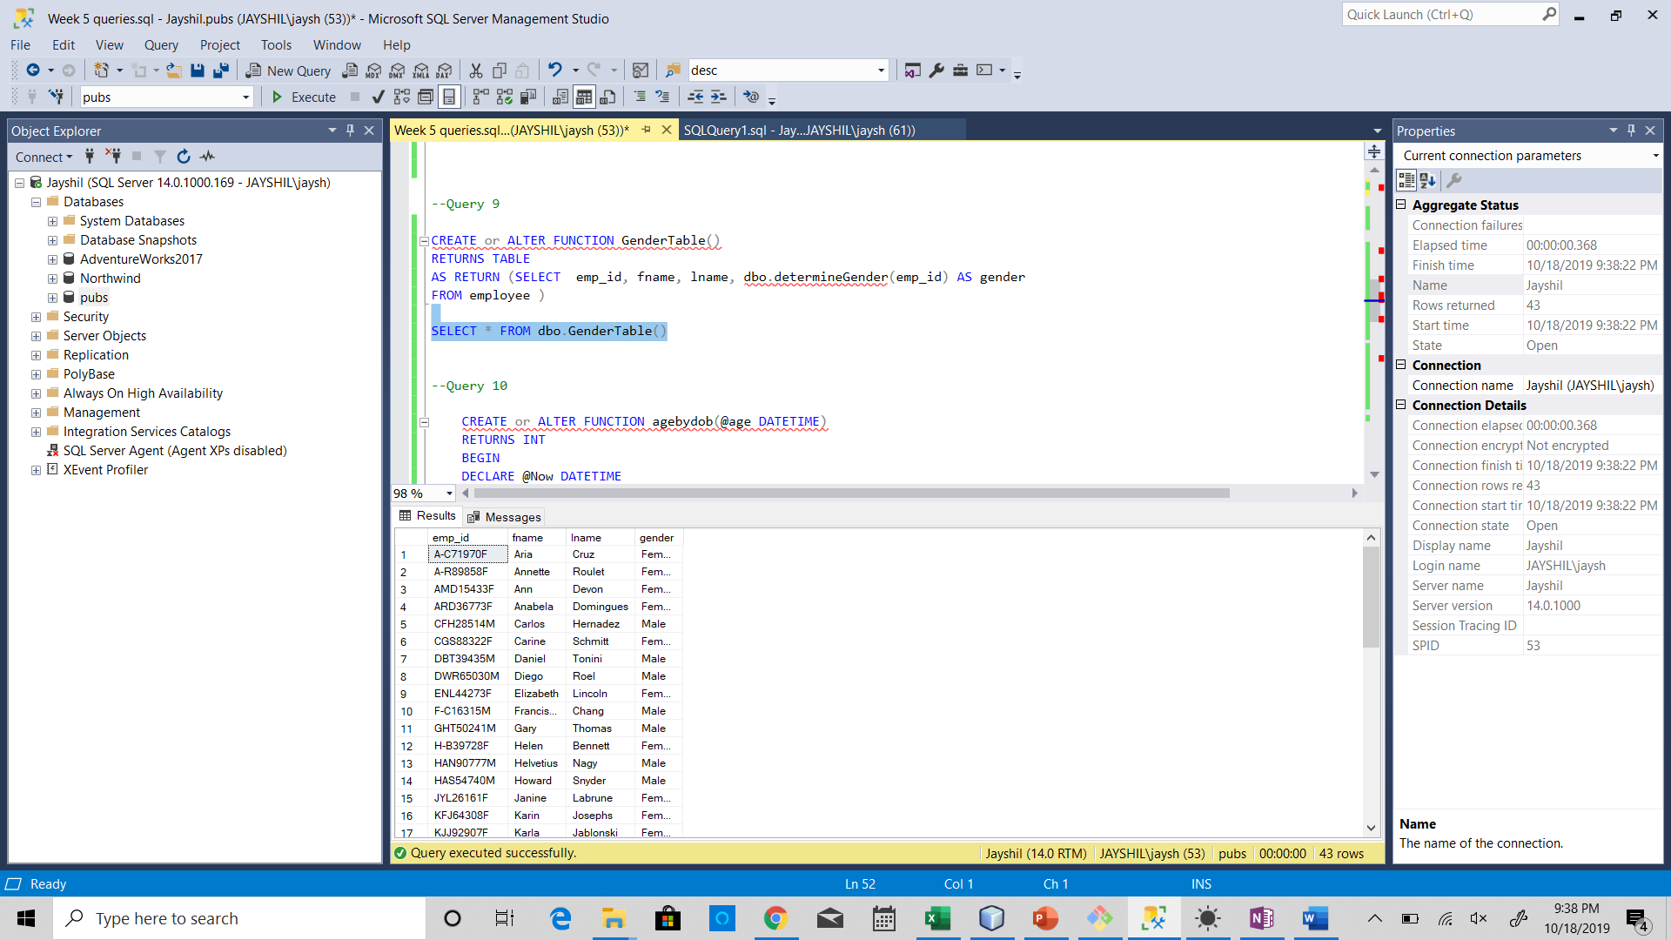

Query 10: Write a function to calculate age in years take into account the birth date

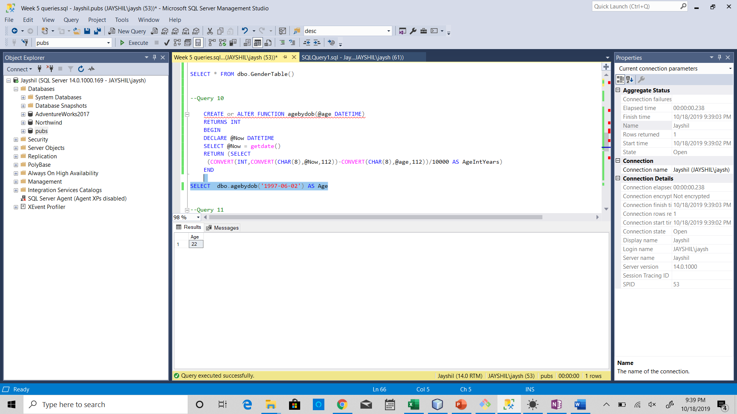

Query 11:

Create a SQLprocedure to insert a record into the jobs table in pubs.  The procedure should validate the input before doing the insert.

